In Whose Name?
Reparative Justice v. the Machiavellian Power of Propaganda
Dave Fleming

Thesis
To avoid the mistakes that led people into the senseless wars and genocide that took place when Europeans took over America, it’s essential to understand the ecosystem of propaganda that got us there and for some, keeps them there. Doing this investigation thoroughly would help people come to terms with why it’s imperative to consider how and where Reparative Justice can help heal and bridge the gap between the Indigenous and Non-Indigenous populations. Where the Colonial Settler era was about tearing things down, our current era needs to be focused on building things up: land rights, environmental balance, communities, culture, and Tribal Spirits all need restoration, protection, and intervention. This requires us to take a moral inventory of ourselves and our history, examining all ways that we’ve been fooled or tricked into believing things that aren’t true. Anything short of that runs the risk of falling into the trap that French philosopher, Voltaire warned us about in 1765:
“Anyone who can make you believe in absurdities,
can make you commit atrocities.”

Reparative Justice
Reparative justice is defined as a process of healing and repairing relationships between perpetrators and victims of harm, with a focus on restoring balance and promoting reconciliation.
As US citizens we should learn what Reparative Justice means and consider where and how we can participate. This opens the possibility of joining in the efforts to reclaim sacred lands, restore burial grounds, support Indigenous-led educational programs, participate in environmental protection efforts, and support the development of culture centers and/or cultural parks that can provide new ways to honor and celebrate Indigenous culture, identity, and history. In addition to these efforts, we should not overlook participating in academic programs that augment initiative to promote more awareness of the Indigenous struggle. Lastly, we can all benefit from projects managed by Indigenous Tribes, for example, the Makoce Ikikcupi Project of Reparative Justice which advocates how to address these horrific historical injustices and promote healing and reconciliation through land recovery.
The Makoce Ikikcupi Project seeks to “bring some of our relatives home, re-establish our spiritual and physical relationship with our homeland, and ensure the ongoing existence of our People. Our cultural survival depends on it.”

Reparative Educational Initiatives
The New England Board of Higher Education (NEBHE) organizes reparative justice around what they call the “Three Pillars: (I) Transformation, (II) Restoration, and (III) Nourish and Uplift. Each pillar addresses specific areas of historical and ongoing harm to BIPOC faculty created by their intentional and systemic exclusion from higher education.” While this form of reparative justice is not reclaiming land, it does contribute to educational programs that can assist in trying to save Native languages as well as providing educational support for reclaiming tribal cultures. It is also important to acknowledge and consider their guidance on the Three Pillars, advising that they “should not be treated as multiple choice options; rather, institutions should address all these areas in their plan. Only focusing on one or two will bring us back to this point where racial inequities abound.”

Understanding Contemporary Propaganda
“In the name of the Queen of England, we do hereby proclaim …” These words were like a template for the royal families of Europe to stake their claim on the new lands they said they “discovered,” using the Papal Edicts such as the Doctrine of Discovery, to inexorably bind and excuse the atrocities carried out in these sea-faring explorations, supposedly doing God’s Will. Centuries later, Americans continue to battle against those who would deny their education, as GOP ``anti-WOKE” campaigns run by conservative factions try to rewrite history or throw it out altogether. Just recently, one of the worst conduits of insidious propaganda, Fox Talk Show Host, Tucker Carlson, has finally been dethroned. The impact of his reign and rage has fed the bonfires of deceit and BIPOC oppression for far too long, contributing to untold violence against the Indigenous and threats to the institution of Democracy during the Jan. 6, 2021, Insurrection. It is both the best and worst example of how Christian Nationalism continues to do everything it can to revive the ideology of Manifest Destiny. This obviously means that we have much work to do in the fight to educate people as well as appealing to their heart and soul.

The essence of the Papal Edicts of 1493 and the Tucker Carlson Edicts of 2009 through 2023 are painfully similar: 1) Malicious misinformation is spoon fed to the masses by an authoritarian figure; 2) Violence is promoted and implied, transforming some of those who follow Fox News into “insta-patriots” or at worst “religious martyrs”; 3) Their power is global and carries penalties if noncompliance should ensue; 4) Great wealth is bestowed upon those who are skillful enough to instill the fear of God in their messages; 5) BIPOC populations suffer the most from the diabolical impact stemming from these High Priests of Deceit.
Even simple logic bites the dust when citizens become too afraid or too lazy or too negligent to answer vital, albeit obvious, questions:
- Can there be “Liberty and Justice for All” when it is not applied to all?
- If we believe that “all men (and women) are created equal,” then how do we reconcile slavery, or racism, or any of the other crimes against a race, solely because they are a different race of human being?
- If we fail to understand the meaning of coexistence, will that be the end of us?

The Impact of the Trojan Horses of Technology
As the Indigenous lands and people were slaughtered, many battles were fought with US Rifles, pistols, and horses. Those were the cutting-edge weapons of that time—weapons that many tribes learned to use, with many of those tribesmen surpassing even the most skilled of the US Calvary. Today’s weapons are a different kind of horse with a different type of power. These are the Trojan Horses of Technology, especially the social media platforms whose initial pitch was the false narrative that when more people are connected online, this will inevitably lead to a unification of people engaged in serving the public good. Instead, Facebook, et. al., soon proved that it had become the world’s most powerful propaganda tool, strong enough to sway elections and reckless enough to evade any and all critical legal remedies to bring them to account.
Why this matters has everything to do with the damage done when phony politicians like Trump’s Regime take over the reins of power in America. And who suffers most from this weaponized technology? Obviously, it’s the BIPOC communities again, and that impact includes negligence, violence, and disinformation so thick, it resulted in the resurgence of Christian Nationalists, the decimation of the EPA, the continued lack of electrical power and internet connectivity to tribes like the Navajo (and many more), deaths mounting from the ravages of the pandemic, and the proliferation of pipelines and drilling on Native American lands. Comparing the call for scalps, advertised on posters after the Dakota War of 1862, to the bloodshed that follows the neo Christian Nationalist movements, contemporary rewards continue to align with the genocidal goals of Colonial Settlers. White Privilege and reckless, ungoverned technology are the Wild West of this era, responsible for the death of thousands of Native Americans who die in hidden ways that won’t be shown on the six o’clock news.
Unfortunately, we continue to fight legal battles with these “too big to fail” tech companies whose billions always seem to successfully sway or pay for the Congressional majority to cast decisive votes in their favor. Yes, some good can come from Facebook and other social media platforms, but the overwhelming negative impact that we are forced to endure is well documented, allowing that age-old mantra of “profits over people” to dominate the government, promote surveillance capitalism, and redefine our social fabric.
Can technology be used for social good? Yes, but the lack of meaningful legislation—as opposed to the effectiveness of the online hate speech laws in Germany—means that we will continue to be oppressed by the owners of these powerful technological weapons. The advent of rapidly evolving AI is another cause for alarm and another challenge for those of us who believe in Reparative Justice. We will all do well to stay vigilant whenever and wherever technology accelerates in an ungoverned manner.
The last word on technology and propaganda must address strategies to expose criminals in our Just-Us system. Whether they are SCOTUS or of the “MTG Wingnut” variety, we must do what we can to hold them to account. It is important to recall that it was not that long ago that the 21st century the Rehnquist Supreme Court was citing cases from the 19th century—as if they had any credibility whatsoever today.

Summary
Regarding my role in Reparative Justice, I’m drawn to research, writing, and filmmaking that I hope to produce, attempting to contribute to raising awareness and hopefully inspire people to see the world from a more expansive, humanitarian perspective.

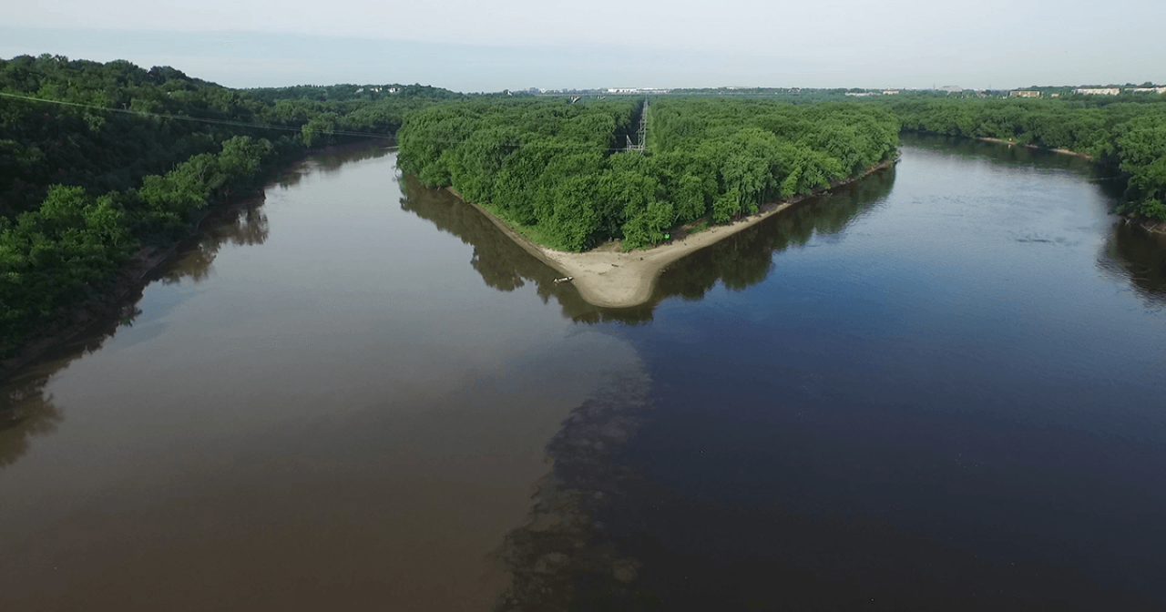
Bdote
When it comes down to the foundations of Reparative Justice, I believe that it is everyone’s obligation to come to terms with the reconciliation of universal love: cultivating love for all brothers and sisters, for the earth, and for all living beings is square one. Collaborating in peace is essential for those of us who know the truth and are ready to look for new pathways to bring us together, owning the past and striving to build a new future. After all, we are one planet, with a shared stewardship of all living things. It’s either coexistence or collapse; There is no other way around it. No matter what propaganda they try to brainwash us with, we must learn to live without prejudice and war.

In closing
Though Reparative Justice has come a long way, it’s critical to remember the toxicity of broken promises and treaties, affecting hearts, minds, and Native American Tribal Lands for untold centuries to come.

Excerpts from: All Our Relations: Native Struggles for Land and Life.
“While Native peoples have been massacred and fought, cheated, and robbed of their historical lands, today their lands are subject to some of the most invasive industrial interventions imaginable. According to the World-watch Institute, 317 reservations in the United States are threatened by environmental hazards, ranging from toxic wastes to clearcuts.”
“Reservations have been targeted as sites for 16 proposed nuclear waste dumps. Over 100 proposals have been floated in recent years to dump toxic waste in Indian communities. Seventy- seven sacred sites have been disturbed or desecrated through resource extraction and development activities.6 The federal government is proposing to use Yucca Mountain, sacred to the Shoshone, as a dumpsite for the nation’s high-level nuclear waste. Over the last 45 years, there have been 1,000 atomic explosions on Western Shoshone land in Nevada, making the Western Shoshone the most bombed nation on earth (not the author’s highlighting).”
- Winona LaDuke, 1999

Bibliography
Harris & Raskin. 2023. The A.I. Dilemma.
https://www.youtube.com/watch?v=bhYw-VlkXTU

Konigsberg. 2014. Who Killed Anna Mae?
https://www.nytimes.com/2014/04/27/magazine/who-killed-anna-mae.html

Winona LaDuke. 1999/2015. All Our Relations: Native Struggles for Land and Life.
Haymarket Books, Chicago, IL

Martin, Jill E., and Robert A. Williams. 2007. Western Historical Quarterly 38, no. 3 : 391–92: Like a Loaded Weapon: The Rehnquist Court, Indian Rights, and the Legal History of Racism in America by Robert A. Williams, Jr. https://doi.org/10.2307/25443579
Minnesota Historical Society. 2023. Bounties.
Excerpted from: David L. Beaulieu. 1970. The Fate of Little Crow, 1863-70. - St. Paul: Beaulieu
https://www.usdakotawar.org/history/aftermath/bounties
New England Board of Higher Education (NEBHE). 2023. Pillars of Reparative Justice:
We organize reparative justice around Three Pillars that address specific areas of historical and ongoing harm to BIPOC faculty.
https://nebhe.org/reparative-justice/pillars-of-reparative-justice/

Satariano & Schuetze. 2022. Where Online Hate Speech Can Bring the Police to your Door https://www.nytimes.com/2022/09/23/technology/germany-internet-speech-arrest.html

Waziyatawin, et.al. 2023. Makoce Ikikcupi: A Project of Reparative Justice.
https://makoceikikcupi.com/
Wilkins, D. E., & Richotte, K. (2003). The Rehnquist Court and Indigenous Rights: The Expedited Diminution of Native Powers of Governance. Publius, 33(3), 83–110. http://www.jstor.org/stable/3331165

